Name:
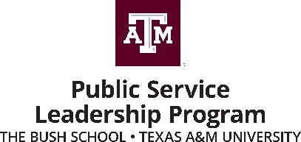

Service Project Participation Reflection

As a joint effort with the Public Service Organization (PSO), the Public Service Leadership Program encourages all students to engage in service projects at the Bush School and within the Texas A&M/Bryan/College Station communities (or the community where you live). The service does not have to be as part of PSO but that is a great place to look! After offering your service, please reflect on your experience using this form and submit it to Holly Kasperbauer.

Describe the service opportunity in which you participated, indicating information about the individuals or organization that benefited from your involvement and the services you provided.

What do you think was your most valued contribution to the project?

How is your service relevant to your personal and professional leadership development?

