Name: Date: / /

Updated June 2021

Individual Leadership Plan
Individual Leadership Plan
“So, the point is not to become a leader. The point is to become yourself, to use yourself completely – all of your skills, gifts, and energies – in order to make your vision manifest. You must withhold nothing. You must, in sum, become the person you started out to be, and enjoy the process of becoming.”
Warren Bennis

Personal Vision Statement | 3
Core Values | 4
Attributes | 5
Skills | 6
Knowledge | 7
Leadership Development Goals | 8
Action Plan | 9
Skills Matrix | 10
Leadership Competency Framework | 11

Leadership development is a process of learning, self-study and personal growth. A structured action plan can jump-start your momentum for personal development and keep you moving toward your goals.

The Individual Leadership Plan (ILP) is an ongoing action plan that can be used to facilitate your development as a leader. In the plan, you assess who you are and envision what you want to become as a leader. In doing so, you will complete a Personal Vision Statement, determine your Core Values, and define personal and professional Leadership Development Goals for the three competency areas for Leadership Development - Knowledge, Skills, and Attributes.

Your final challenge will be to determine an Action Plan that guides you through steps to take in order to move from your current reality to the achievement of each goal.
To be a Principled Leader, you must InVEST in Yourself!

Personal Vision Statement
“No man that does not see visions will ever realize any high hope or undertake any high enterprise.”
Woodrow Wilson, 28th President of the United States

Before you can lead others, you must be able to lead yourself. A personal vision statement entices you to think about your life, clarify its purpose and identify what is really important to you. Invest time reflecting on the things that are central to your being in order to answer the question, “Who am I and what is my higher calling?” After writing your vision statement, use it as the standard by which you judge your activities and choices.

The following suggestions from The 7 Habits of Highly Effective People by Stephen Covey may help you capture what is succinctly central to your being.

- A personal vision statement focuses on what you want to be (character) and to do (achievements and contributions) and on the principles upon which being and doing are based.

- A personal vision statement becomes a personal constitution, the basis for making major, life-directing decisions, the basis for making daily decisions in the midst of emotion and circumstances that affect our lives.

- The personal vision statement may be written in a variety of ways. Some may choose lists, paragraphs, to poems. “Because each individual is unique, a personal mission statement [should] reflect that uniqueness, both in content and form.”

- Once you have a sense of mission/vision, you have the essence of your own proactivity. You have the vision and values which direct your life. You have the direction from which you set your development goals. Most importantly, you have the power of a written constitution, against which every decision can be effectively measure.

Please create your Personal Vision Statement below.

After you have written a draft of your Personal Vision Statement, evaluate it by asking yourself:
Do I feel this vision statement represents the integrity I stand for?
Are direction, purpose, challenge, and motivation signaled in this vision statement?
Am I aware of the strategies and skills that will help me accomplish what I have written?
If I were to share my Personal Vision Statement with the world, is this an accurate portrait of who I want to be?
Final Test: Does this vision statement inspire me?

Core Values
It’s not hard to make decisions when you know what your values are.”
Roy Disney

Your core values are the principles you use to govern your life and define integrity and ethics for you. Effective leaders hold fast to these standards and do not waver, using them to help weigh choices in life. Every effective leader has a list of things they believe to be of worth, quality or esteem. They are the things the leader prizes and is willing to “go to bat” for.

Your values will most likely compliment your Personal Vision Statement. Furthermore, make sure any goals and action plans you develop are consistent with your values.

To prioritize your values, identify 8-12 that are most important to you below.

Achievement – some sense of accomplishment, mastery, goal attainment
Advancement – growth, seniority, and promotion resulting from work well done
Adventure – some sense of accomplishment, mastery, goal attainment
Affiliation – interaction with other people, recognition as a member of a particular group, involvement, belonging
Affluence – high income, financial success, prosperity
Authority – position and power to control events and other peoples’ activities
Autonomy – ability to act independently with few constraints, self-reliance, ability to make decisions/choices
Balance – lifestyle that allows for a balance of time for self, family, work, and community
Challenge – continually facing complex and demanding tasks and problems
Collaboration – close, cooperative working relationships with groups
Community – serving and supporting a purpose that supersedes personal desire, “making a difference”
Competency – demonstrating high proficiency and knowledge, showing above-average effectiveness and efficiency at tasks
Competition – rivalry with winning as the goal
Courage – willingness to stand up for one’s beliefs
Creativity – discovering, developing, or designing new ideas, formats, programs, or things; demonstrating innovation and imagination
Diverse Prospectives – unusual ideas and opinions, points of view that may not seem right or popular at first but bear fruit in long run
Duty – respect for authority, rules, and regulations
Economic Security – steady and secure employment, adequate financial reward, low risk
Enjoyment – fun, joy, and laughter
Fame – prominence, being well known
Friendship – close personal relationships with others
Health – physical and mental well-being, vitality
Helping Others – helping people attain their goals, providing care and support
Humor – the ability to laugh at oneself and life
Influence – having an impact or effect on the attitudes or opinions of other people
Inner Harmony – happiness, contentment, being at peace with oneself
Integrity – acting in accordance with moral and ethical standards; honesty, sincerity, truth, trustworthiness
Knowledge – the pursuit of understanding, skill, and expertise; continuous learning
Loyalty – faithfulness; dedication to individuals, traditions, or organizations
Personal Development – dedication to maximizing one’s potential
Responsibility – dependability, reliability, accountability for results
Self-Respect – pride, self-esteem, sense of personal identity
Spirituality – strong spiritual or religious beliefs, moral fulfillment
Wisdom – sound judgment based on knowledge, experience, and understanding
From the values selected above, identify 3-5 Core Values that align most closely with ‘Who you are” (from PVS) and “Who you want to be.”

1.
2.
3.
4.
5.

Attributes Analysis
“Imagine the [leadership] styles, then, as the array of clubs in a golf pro’s bag…the pro ‘senses’ the challenge ahead, swiftly pulls out the right tool, and elegantly puts it to work.”
Goleman, Boyatzis, McKee

Effective leaders know their personal strengths, their areas in need of improvement, the characteristics they display in their relationships with others, and their preferences towards specific situations. They also understand that taking strategic and proactive approaches to developing and managing their professional image pays off. In summary, effective leaders have self, social, and situational awareness, and manage themselves and their relationships.

The good news is that you can be the author of your own identity. Spend some time below reflecting on your approach and needs for developing your own image.

Your Desired Professional Image
What do you want key constituents to say about you when you are not in the room (your core competencies, strengths and character traits)?

Your Current Image, Culture, and Audience.
What are the expectations for professionalism in the field you are pursuing?

How do others currently perceive you?

Strategic Self-Presentation
What stereotypes correlate with your intended profession and how will you handle them?

How will you build credibility while maintaining authenticity?

Information for “Attributes Analysis” was retrieved from an article by Mallory Spark about Professor Laura Morgan Roberts’ expertise in Professional Images http://hbsworkingknowledge.hbs.edu

Leadership Skills

Skills are the abilities that leaders use to translate their syles, strategies and plans, tools and techniques into practice. Identifying skills for development requires a level of self-reflection (Step 1) to determine those skills you have developed and used in previous leadership/professional opportunities. It also requires self-trajection (Step 2), thinking about the skills that will be important to your future success.

Step 1:
Identify skills you have developed and used in previous leadership/professional opportunities. In particular, think about skills that make you marketable to a prospective employer (what are the skills you list on your resume). The goal is not only to list what you are good at doing, but also to produce solid examples of how you previously applied those skills in work or leadership roles to achieve positive outcomes. Take time to also reflect about your leadership strengths (as identified by the StrengthsQuest assessment and your personality preferences).

For guidance, please access the “Skills Matrix” attachment at the end of this document.
Skill | Highlight the task, method, purpose, value, and outcome. (from Skills Matrix)

Step 2:
Below is a list of skills that many organizations, government agencies and large/small businesses deem important for leadership roles. Put a check by those skills that you feel you could improve. Another way to identify skills that organizations deem important is to find a job description in the area you are most interested in for a career. Circle the skills outlined in the job description that you need to attain or further develop. You might choose to focus on skill areas that you are already good at, but by strengthening them, you will be a more effective leader.

Personal Skills
Developing Self Awareness
Managing Personal Stress
Solving Problems Analytically and Creatively

Interpersonal Skills
Coaching, Counseling, and Supportive Communication
Gaining Power and Influence
Motivating Others
Managing Conflict

Group Skills
Empowering and Delegating
Building Effective Teams and Teamwork
Managing Change

Technical Skills
Making Oral and Written Presentations
Policy Analysis
Economic Analysis
Personnel Management
Budgeting
Project Management
Language Proficiency

Other Skills (Think about the skills that job announcements in your intended field emphasize)

Step 3:
From Steps 1 & 2, identify 1-3 skills on which you would like to focus. As you continue to complete your Individual Leadership Plan, you will reflect on these skill areas and develop goals related to them.

1.
2.
3.

Knowledge
“A hallmark of achievement is in continually learning – and teaching – ways to do better.”
Goleman, Boyatzis, McKee

Effective leaders spend time studying the field of leadership and management. All leaders need information, and they have to be able to process that information in the best manner possible. Effective leaders know when to be critical and analytical in their thinking, when to be creative, and when to take the time to think conceptually.

On the previous page, you identified potential areas of growth for leadership skills. Webster’s Dictionary definition for skill: the ability to use one's knowledge effectively and readily in execution or performance. Complete the following matrix, which will help you determine particular areas where you should gain more knowledge and/or experience for the skills identified on page 6 (Leadership Skills Section)

You do not have to complete the matrix. If you only chose 2 skills, just fill in 2 lines.
Skills (transferred from page 6) | What do you understand? | What Experience do you have? | What Development Needs do you have?
Ex.  Managing Change | Change is inevitable; not being open to change risks personal and professional growth; most people have a negative attitude toward change. | Leader of an organization that was analyzing past goals and objectives and creating new ones in order to better serve members and community. | Gain information and experience in how to get others motivated about change; create change without setting off a state of panic
1.
2.
3.

Leadership Development Goals

Using the information obtained from analyzing your Attributes, Skills, and Knowledge, develop 2-3 STRETCH Leadership Development Goals and 1-2 Manageable Goals per STRETCH Goal. Although you may be enticed to develop multiple goals, studies show that working on too many goals could decrease the probability of achieving any of them. These goals should directly be related to the skills you listed on page 6 (Leadership Skills section) in Step 3.

STRETCH Goals are challenging goals that will result in a breakthrough toward reaching your Personal Vision Statement.

MANAGEABLE Goals are *S.M.A.R.T. goals that will help you get started toward your STRETCH Goals and Vision.

- STRETCH Goal :

- Manageable Goal:

- Manageable Goal:

- STRETCH Goal :

- Manageable Goal:

- Manageable Goal:

- STRETCH Goal :

- Manageable Goal:

- Manageable Goal:

*Use the 5 S.M.A.R.T. Goal Guidelines below:
Specific—a specific goal has a much greater chance of being accomplished than a general goal. Ask yourself the six “W’s” (Who, What, Where, When, Which, Why)

Measurable—establish concrete criteria for measuring progress toward attaining each goal. When you measure your progress, you stay on track. To determine if they are measurable, ask questions such as…How much? How many? How will I know when it is accomplished?

Attainable—when you identify goals that are most important to you, you begin to figure out ways you can make them come true. You can attain most any goal you set when you plan your steps wisely and establish a time frame that allows you to carry them out.

Realistic—to be realistic, a goal must represent an objective toward which you are both willing and able to work. Your goal is probably realistic if you truly believe that it can be accomplished. Ask yourself what conditions would have to exist to accomplish the goal.

Timely—a goal should be grounded within a time frame. With no time frame tied to it there’s no sense of urgency. “Someday” won’t work, but if you anchor your goal within a timeframe, then you’ve set your unconscious mind into motion to begin working.

Action Plan

“Authoritatively setting directions about performance aspirations has multiple benefits: it energizes team members, it orients their attention and action, and it engages their talents.”
J. Richard Hackman

Your Action Plan identifies very specific steps you will take, resources you will locate, and the support system you will build to reach your Leadership Goals and work toward your Personal Vision. It moves you from “Current Reality” to achieving your goals. This is your plan for achieving the goals you listed on the previous page.

Complete the plan below and use the information to jump-start your development.
Goal #1 | Specific Actions to Take (what are the specific tasks you are going to complete to achieve your goal) | Resources to Assist Development (are there books, articles, websites, or people who can help you) | Timeline (by what date will you accomplish your goal)

Goal #1 | Specific Actions to Take (what are the specific tasks you are going to complete to achieve your goal) | Resources to Assist Development (are there books, articles, websites, or people who can help you) | Timeline (by what date will you accomplish your goal)

Goal #1 | Specific Actions to Take (what are the specific tasks you are going to complete to achieve your goal) | Resources to Assist Development (are there books, articles, websites, or people who can help you) | Timeline (by what date will you accomplish your goal)

Attachment 1: Skills Matrix
Since the job search process mirrors that of a marketing campaign the first step is to identify the customer and his or her wants and needs. After determining what the customer, or in this case the employer, wants you must determine whether and how you can meet their requirements. This page is OPTIONAL and is intended to help you complete Step 1 from the Leadership Skills section on page 6. The skills you list here are skills that you have a strong background in already. Feel free to use what you know about yourself from taking the StrengthsQuest assessment or the Myers-Briggs Type Indicator.

Step 1:
Potential employers want to hear about specific skills you can contribute that will strengthen their organization. Take some time to reflect on what specific knowledge, skills and abilities you can contribute to an organization at this point in your career. Your previous leadership, volunteer and work experiences are a good starting point in this self-reflection.

Step 2:
Build the matrix by describing the following using the START approach:
- (S) – Situation
What did you do? What was the situation? You should describe it in enough detail that someone with no understanding could comprehend the situation.
- (T) – Task
What was required in the situation? What steps or responsibilities were required of you?
- (A) – Action
What did you do? How did you do it? What was your contribution to the task and situation?
- (R) – Results
What happened because of your actions? How did your work contribute to the overall purpose?
- (T) – Takeaways
What were the key learning principles that you took away from the experience? How does this transfer to other experiences?

Note that this matrix will grow throughout your academic and professional career and will benefit you through the job search process and enhance your career management success. In the job search process, this matrix will help you in targeting your resume to meet the needs of the job in which you are applying, writing a cover letter, interviewing and networking.

Points to note:
- You may have multiple examples or only one example for each skill.
- Quantify whenever you can. How many? How much? Dollars? Percentages?
- Think along the lines of how you purchase products or services. You want to know what something does, how, why, and the results. Those are all needed to close the sale of a product or service – that is no different than what you are trying to do as you search for a job.

Skill | Situation | Task | Action | Results | Takeaways

Attachment 2: Leadership Competency Framework

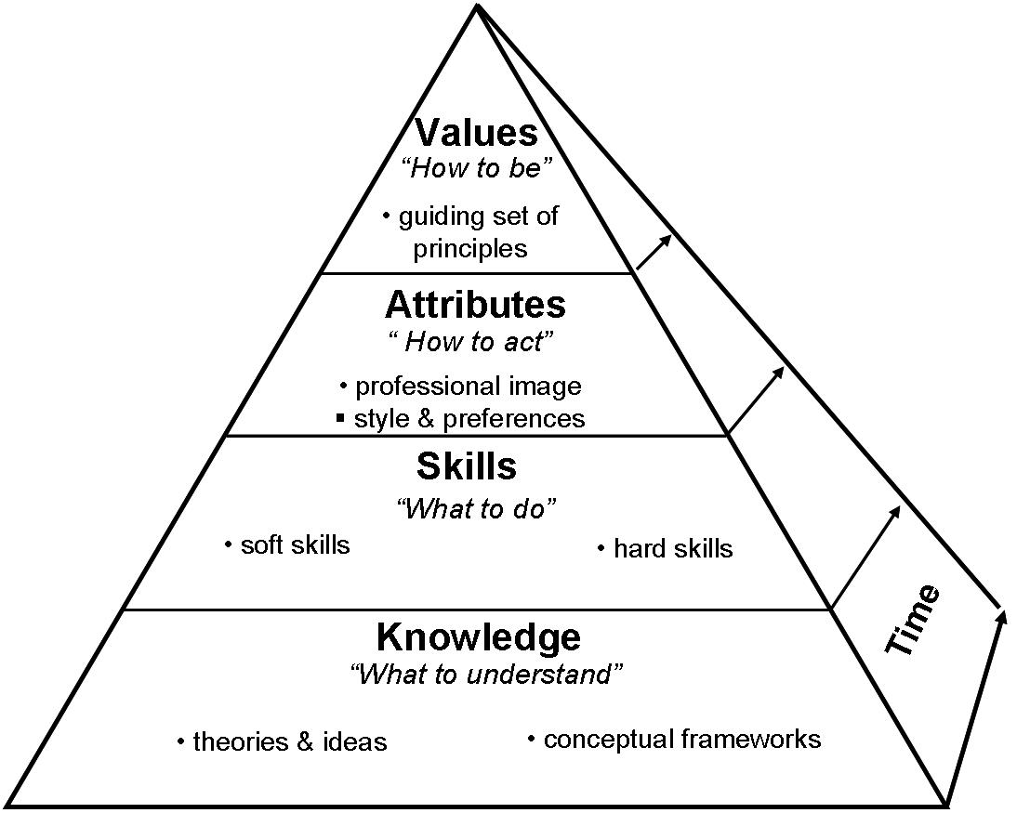
Starts with Vision:

Who am I?
What do I want to become?

