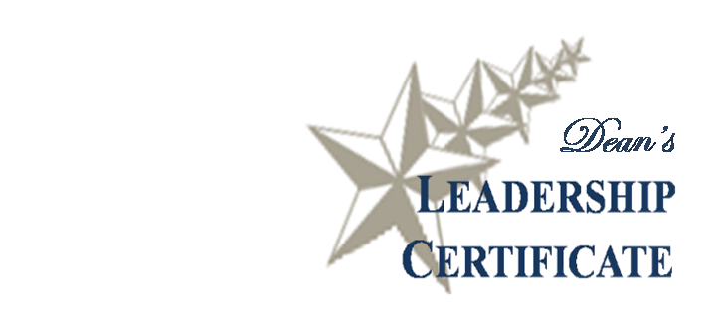
Formal Leadership
Requirement

Experience Form

The Bush School and the Texas A&M Community provide numerous opportunities for experiential leadership development. To meet the requirements for the Leadership Certificate, Bush School students should fulfill a formal leadership role during their two-year degree program, complete this form, and submit it to Holly Kasperbauer (1023).

Describe your Formal Leadership Experience, indicating your formal role and responsibilities and describe the group/organization/team you led.

In what ways did your leadership experience “stretch” you to learn new things or change your approach or perspective?

What is something you want to work on/improve upon – that you identified during your leadership experience?

