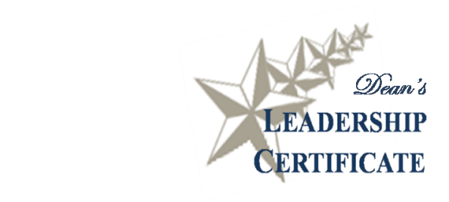
Name:

Dean’s Leadership Certificate Checklist

Formal Education and Workshops

Completed four workshops

Self-Study and Assessments

Completed at least two leadership assessments – can include Learning Styles Inventory, StrengthsQuest, MBTI, Personal Values Questionnaire, DiSC (or other approved assessment)

Completed and submitted my Individual Leadership Plan (ILP)

Completed my individual coaching session (final semester)

Experiential Learning Activities

Submitted Leadership Experience reflection form

Submitted Service Project Participation reflection form

More questions? Please contact Holly Kasperbauer, PSLP Assistant Director hjkasperbauer@tamu.edu

